SAMPLED VERIFICATION REPORT
Deal Number | NDLLAPCHN0063297 |  | Branch |  | Chennai
Product | RLAP |  | Program |  | -
SM / RM Name | NA |  | DSA |  | NA
Applicant’s Name | PRABHAKHAR D |  | Co-applicant’s Name |  |  | Prabhakar / Malliga
Company Name | PRABHAKHAR D |  | Pick Up Type |  |  | Mandatory
Applied Loan Amount | ₹300,00,000/-
Sampled Date | 22-09-2026 |  | Report Date | 25-09-2026 |  |  | TAT | 01
Documents Sampled | Business profile + Resi profile +
Dedupe Match Details | No Match Found
Overall Remarks | Business Verification: We visited the given office address for verification. The name board displayed at the location was “Cams Pal’s Baaar.” We met the Applicant, who confirmed that he has taken the kitchen/catering contract work inside the Bar and has been carrying out the contract for approximately 12 years. He stated that around 10 persons are working under him, and we observed approximately 10 workers at the location during our visit. He confirmed that he is the proprietor of the kitchen/catering contract business and is engaged only in the internal kitchen/catering operations of the hotel. A name board mentioning his name and “Proprietor” was displayed at the kitchen room entrance. The business setup and operations were found at the given location. We also cross-checked with the persons working inside the premises, who confirmed that he is undertaking the kitchen/catering contract work at the Bar. Status: Positive.  Property Verification: We visited the given property address at 1/19, V.V. Kovil Street, Chimmiya Nagar, Chennai – 600092 and conducted the property verification. We met Mr. Sasikumar, who is the applicant's manager. He confirmed that the property is owned by Mr. Prabhakar. The property is a commercial building with an approximate area of 7,148 sq. ft. and an estimated market value of ₹22 Crores. The property is currently tenant occupied by 7 tenants and is being used for commercial purposes. Neighbour confirmation was obtained and found to be satisfactory. No specific property-related problems/issues were observed.The property address and physical existence were verified during the visit. Overall Status: Positive.  ITR Verification : The Given ITR in the Name of DHANAPAL PRABHAKAR Pan card number AALPP6618A Acknowledgment no 144113670311225 with Income Tax Office for AY 2025 26 and found that Gross total income amount is Rs.1991768 /-Tax paid Rs.176876/- date of filing is 31/12/2025 is Matching with the Income tax copy, Status Positive.  Bank Statement Verification : We have checked the given banking of SBI BANK Account Number 20098048133 in the name PRABHAKAR is matching with bank statement provided and it is saving account opened Date is Not Provided and Credit transaction date 01/08/2026 is Rs.24370/- and Credit transaction date 25/08/2026 is Rs.27078/- and Credit transaction date 02/09/2026 is Rs.27000/-, are matched with given bank statement, Status: Positive  Patta : Given Patta was verified with Online services and found the details was matched with records, Status: Positive
Status | POSITIVE
Verifier Name | THAMEEM
Vendor Name, Seal & Stamp | SKY LINE RISK AUDIT SERVICES
Photographs of Residence/Business
OFFICE PHOTO:

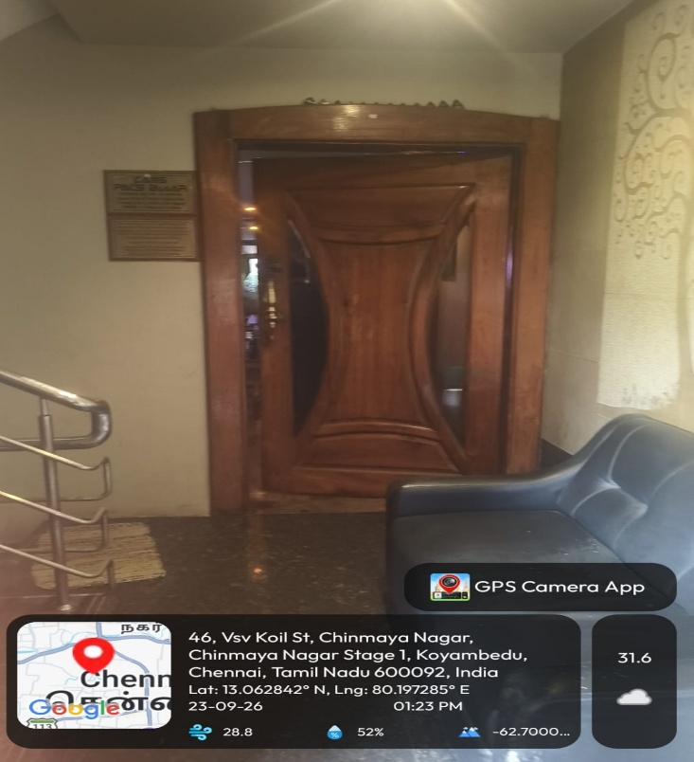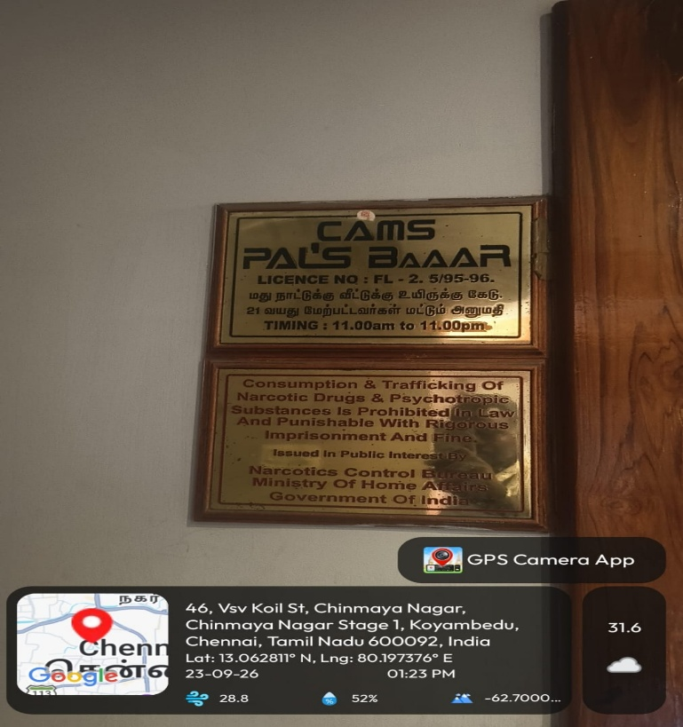

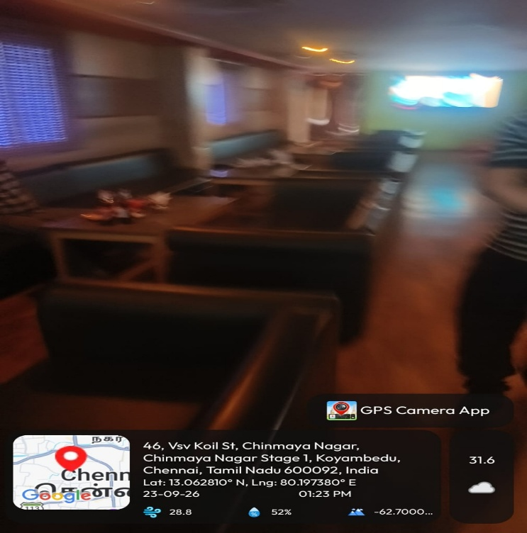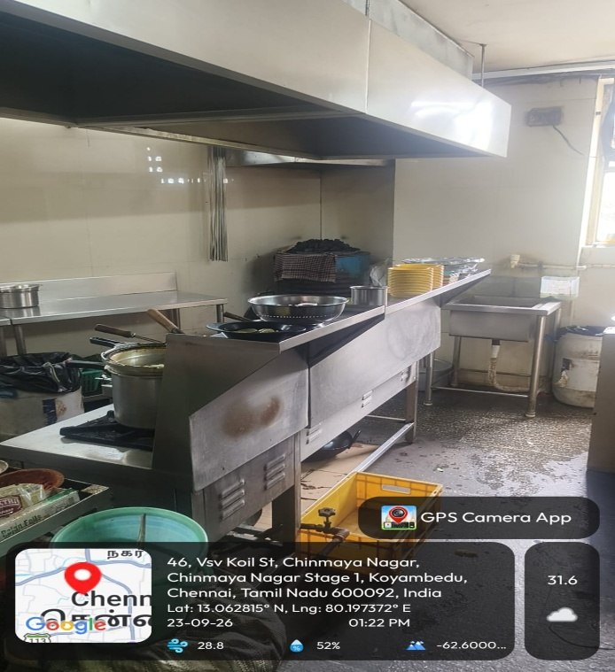

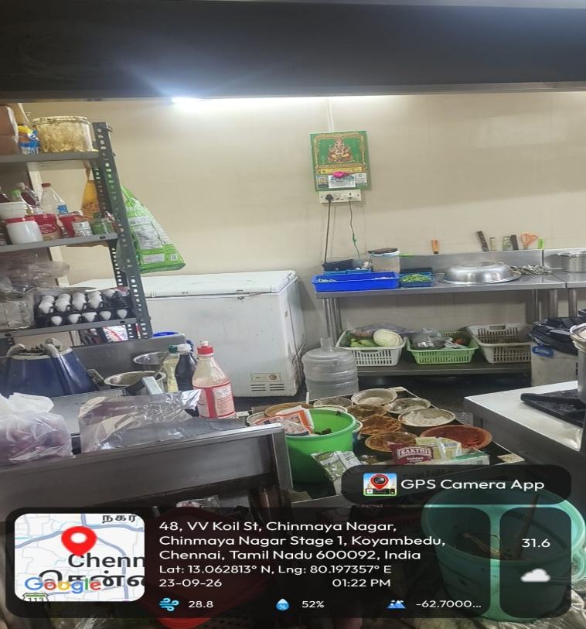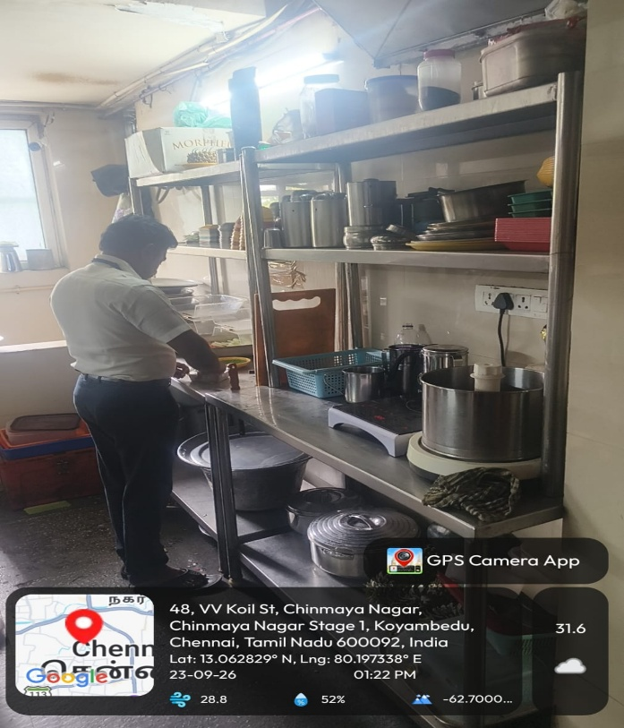

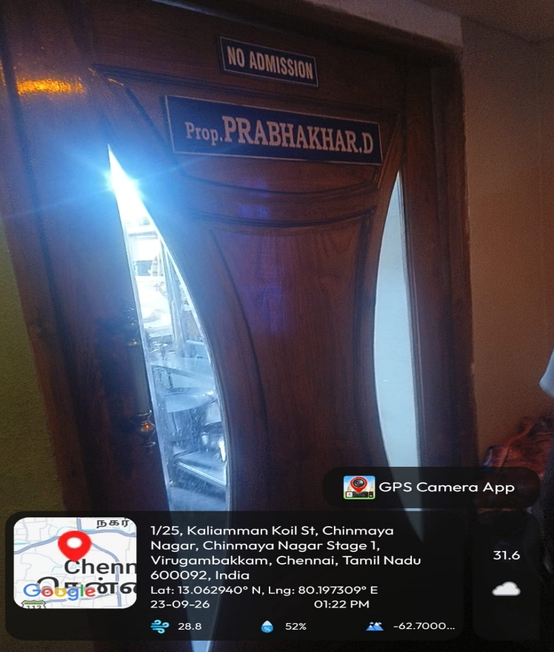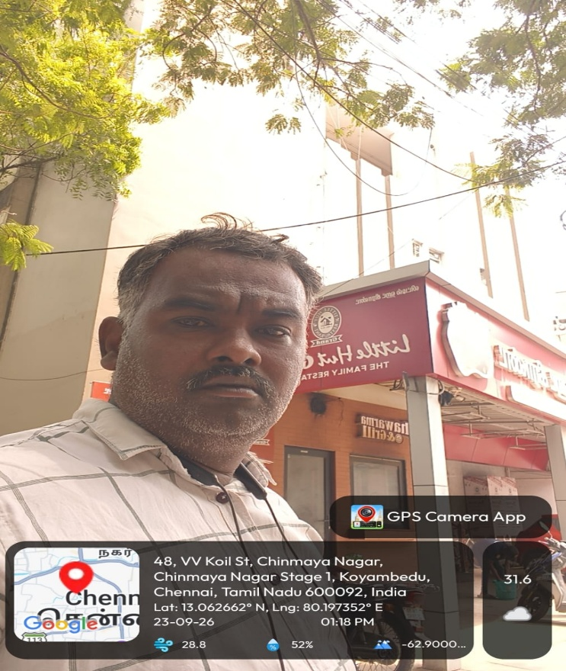

Photographs of Property |  | 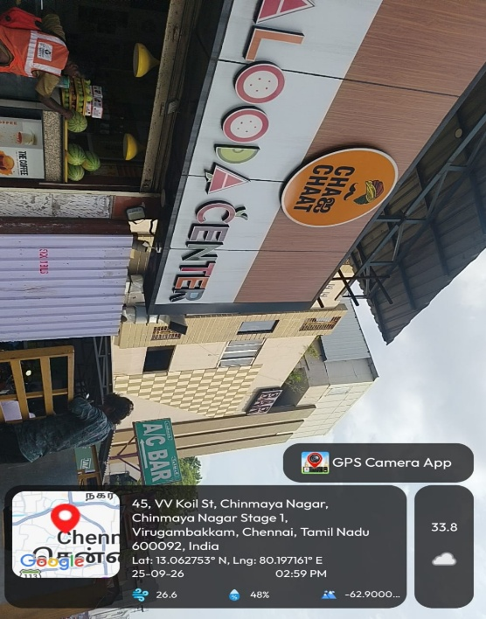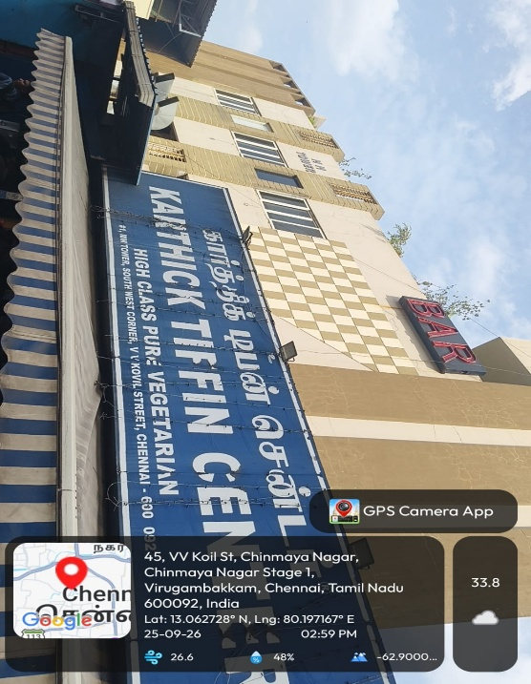  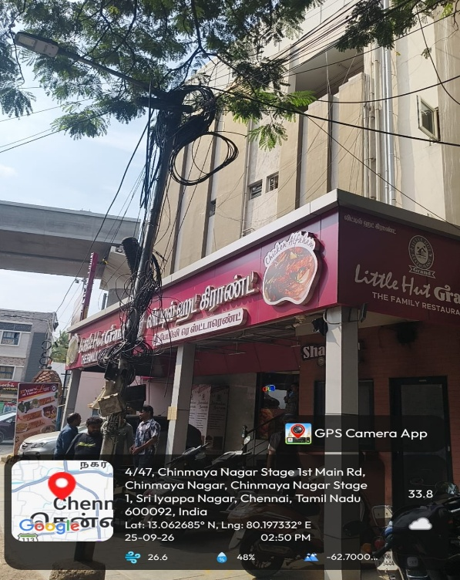
NA
Vendor Name, Seal & Stamp |  | SKY LINE RISK AUDIT SERVICES

Patta Online Verification :
